**UAE SME Growth Analysis using Python Power BI and ML**

**Project Report**

**Business Problem**

Small and Medium Enterprises (SMEs) are crucial to the UAE’s economy, contributing to employment, innovation, and GDP. Despite their importance, SMEs face challenges such as high customer churn, limited diversification, dependency on traditional sales, and underutilization of digital tools.

This analysis aims to: - Measure SME revenue performance and growth trends.

- Identify factors driving customer churn and retention.

- Compare marketing spend against sales outcomes.

- Understand SME performance across industries and Emirates.

- Provide actionable strategies to improve revenue, customer loyalty, and scalability.

**Exploratory Data Analysis Insights**

**Summary Statistics**

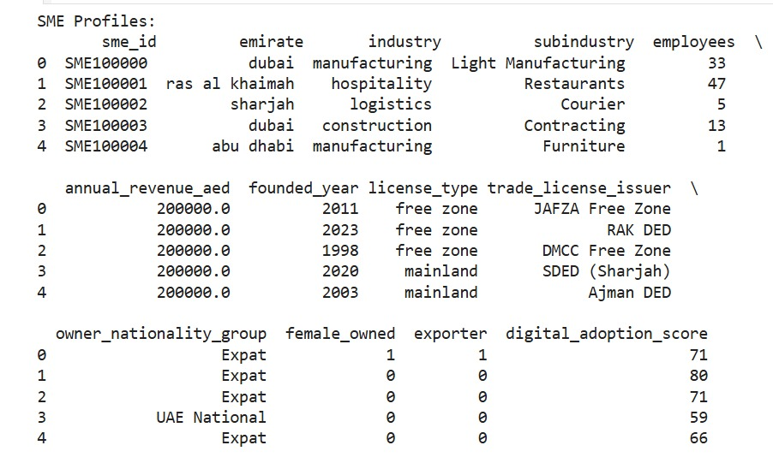

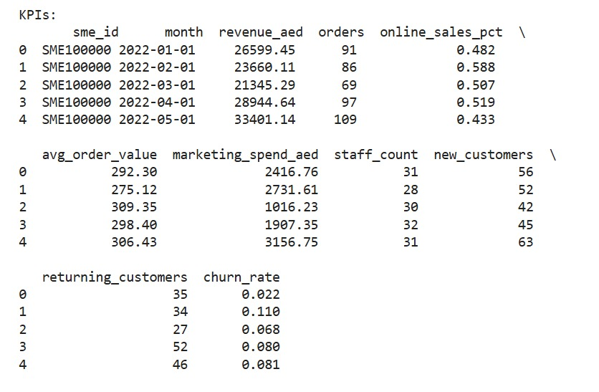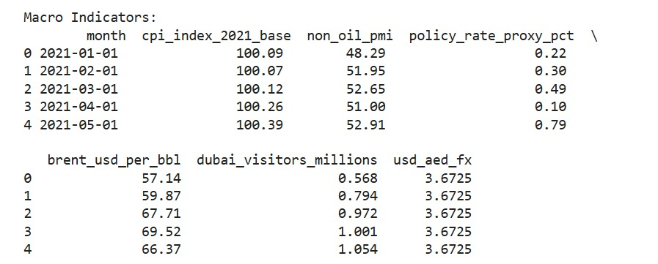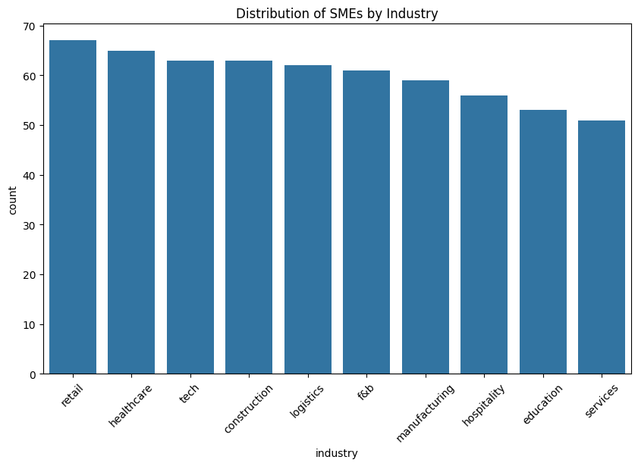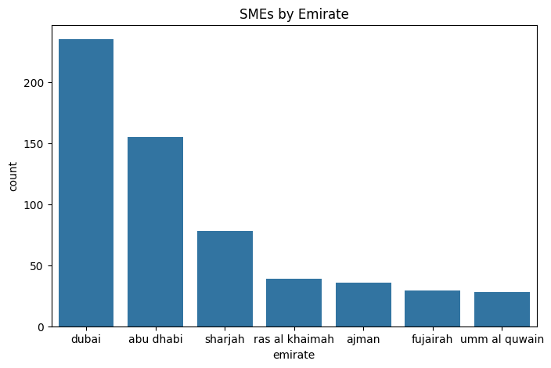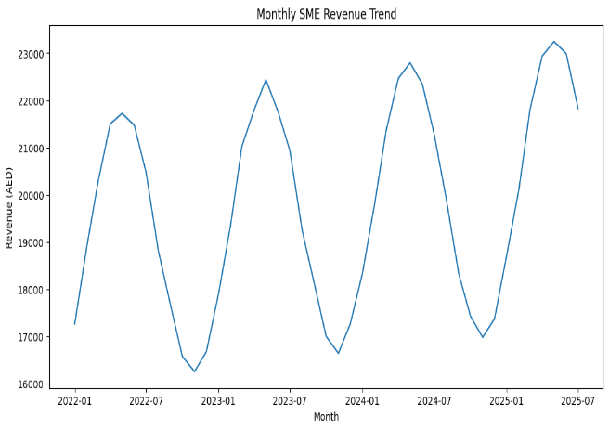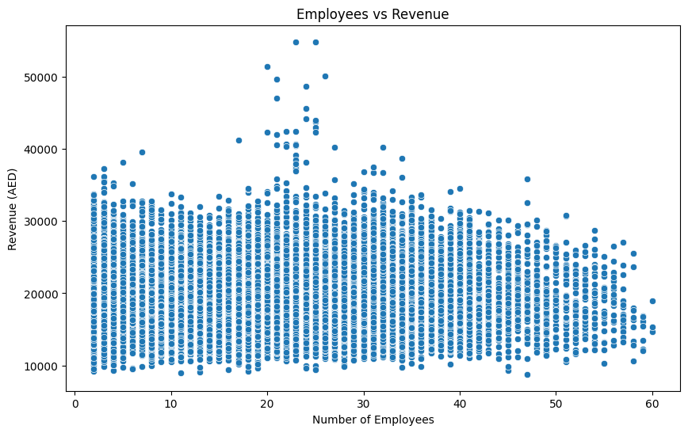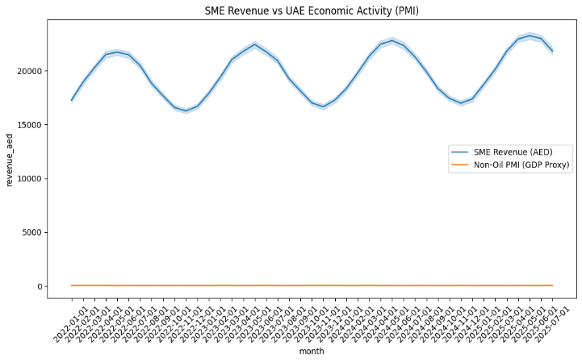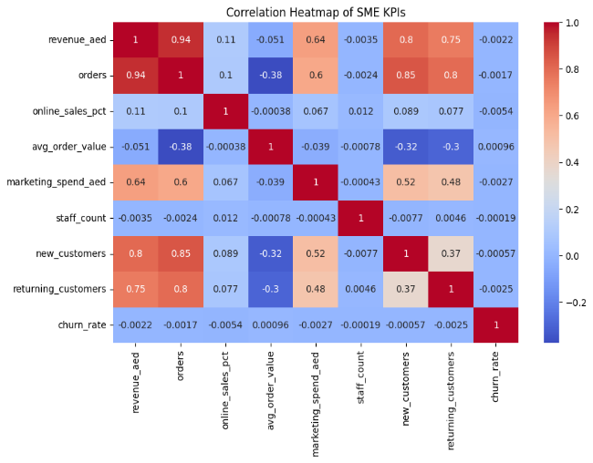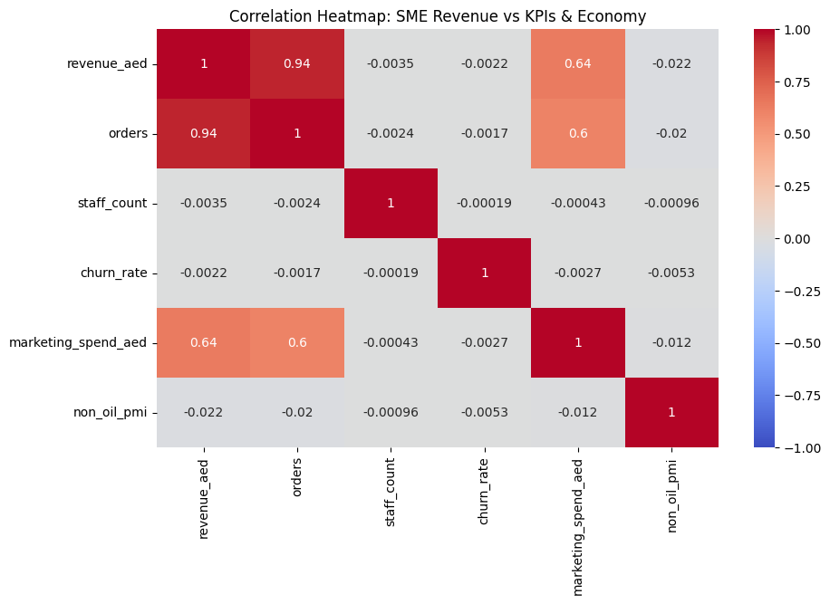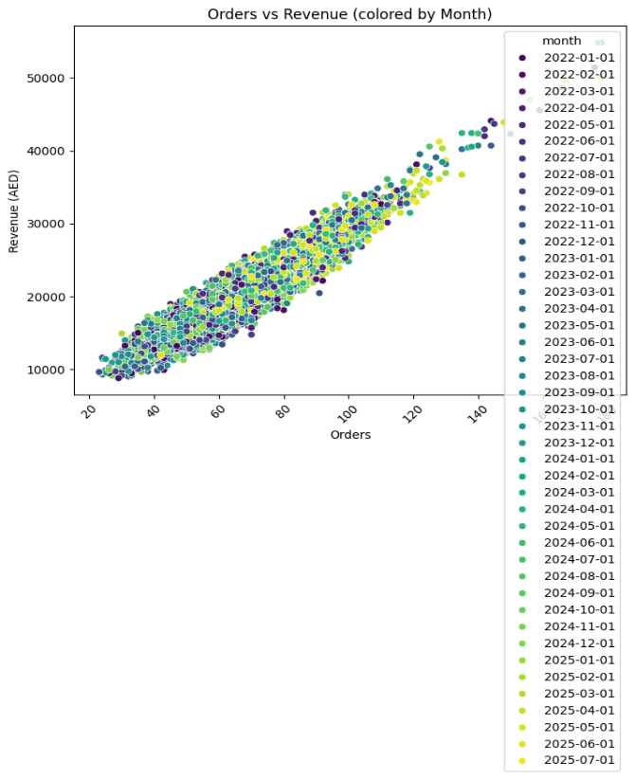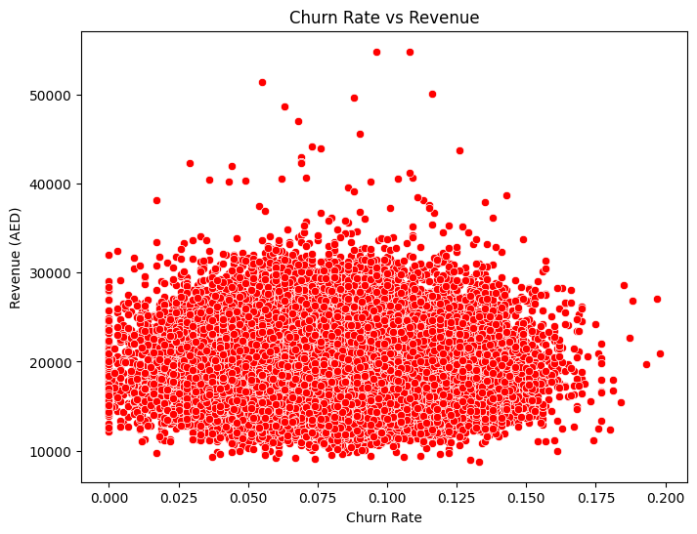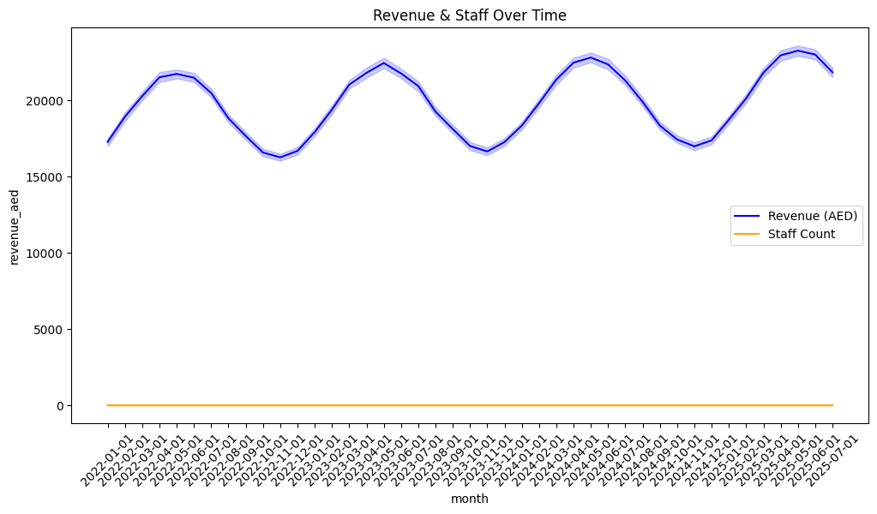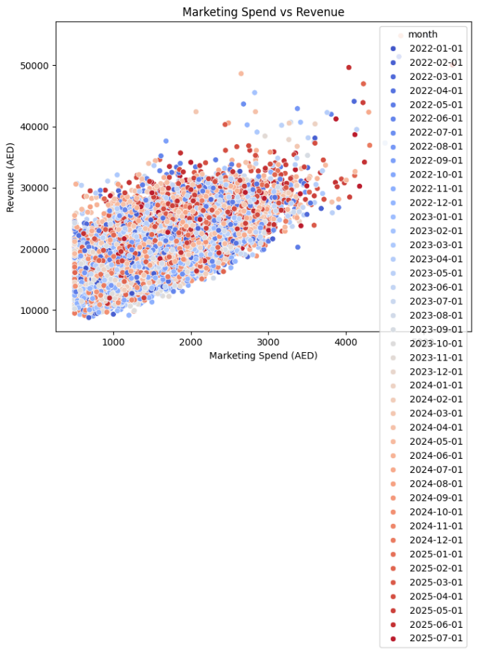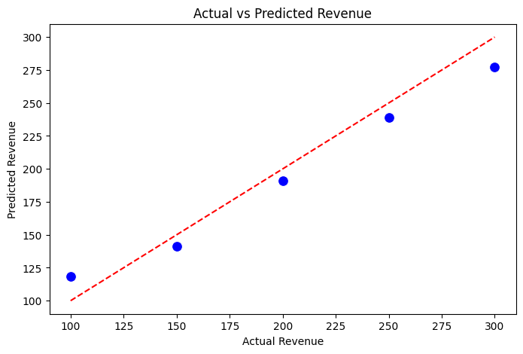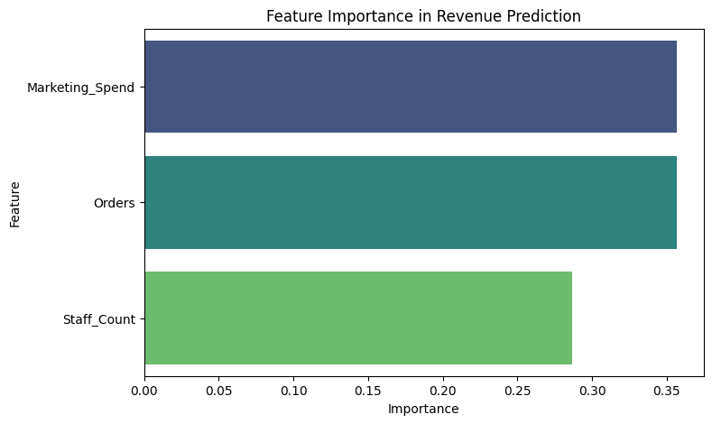

**Key Metrics from Dashboard: -**

Total Revenue: $1.12M

- Average Order Value (AOV): $118.06

- Churn Rate: 449.1%

- New Customers: 2,124

* Revenue Trends: Revenue has remained fairly stable from 2022 to early 2024 with fluctuations, but actual revenue occasionally falls short of predicted values.
* Marketing & Sales: Marketing spend shows moderate correlation with sales, but efficiency decreases at higher spending ranges.
* Customer Segments: Returning customers account for 56.22% of total, while new customers contribute 43.78%.
* Regional Distribution: Highest contributions come from Dubai and Sharjah, while other Emirates such as Ajman and Umm Al Quwain show smaller shares.

**Data Filtering**

* To ensure meaningful insights, analysis focused on: -
* SMEs with consistent sales and order values. –
* Industries with significant representation: Construction, Education, F&B;, Healthcare. - Emirates with measurable revenue contributions

**Correlation Insights**

- Marketing Spend vs Sales: Moderate positive relationship.

- Customer Retention vs Revenue Growth: Strong correlation.

- SMEs with higher returning customer ratios perform better financially.

- Geography vs Revenue: Emirates with larger populations (Dubai, Sharjah) show higher SME revenue

**Research Questions & Key Findings**

1. Which industries show stronger SME growth?

- F&B; and Healthcare SMEs show higher customer acquisition and recurring revenue.

2. Which Emirates contribute the most?

- Dubai and Sharjah dominate SME revenue share.

3. How does churn affect SMEs?

- Extremely high churn rate suggests retention challenges.

4. Do marketing investments lead to growth?

- Yes, but diminishing ROI observed.

5. Are SMEs building customer loyalty?

- Returning customers (56.22%) are slightly higher than new (43.78%)

**Statistical Validation**

Hypothesis:

SMEs with stronger returning customer base achieve higher revenue stability.

Result:

Hypothesis supported; returning customers significantly contribute to predictable sales streams

**Final Recommendations**

1. Customer Retention Focus: Introduce loyalty programs, subscription models, and after-sales support to reduce churn.

2. Optimize Marketing Spend: Shift from broad campaigns to digital targeting and analytics-driven marketing.

3. Geographic Expansion: Leverage growth potential in Ajman, Fujairah, and Ras Al Khaimah.

4. Digital Transformation: Encourage SMEs to adopt e-commerce platforms, CRM tools, and digital payments.

5. Industry-Specific Strategy: - F&B;: Focus on delivery apps & promotions. - Education: Scale online learning solutions. - Healthcare: Adopt telemedicine & digital booking systems. - Construction: Improve procurement efficiency.

6. Data-Driven Decision Making: SMEs should monitor KPIs (revenue, churn, customer retention, marketing ROI) through dashboards for proactive strategy adjustments